End of Unit Test – Networking

- The following table contains statements about computer networks.
Tick one box in each row to show whether each statement is true or false.
 | True | False
A standalone computer is one that is connected to a network, but not to the Internet
A standalone computer is more secure than a networked computer.
The Internet is an example of a Wide Area Network
[3]
- A user types the address www.ocr.org.uk into a web browser.
Describe how a DNS server is used to access this website and explain the advantages of using DNS servers.
The quality of written communication will be assessed in this question.
…………………………………………………………………………………………………………………
…………………………………………………………………………………………………………………
…………………………………………………………………………………………………………………
…………………………………………………………………………………………………………………
…………………………………………………………………………………………………………………
…………………………………………………………………………………………………………………
…………………………………………………………………………………………………………………
…………………………………………………………………………………………………………………
…………………………………………………………………………………………………………………
…………………………………………………………………………………………………………………
…………………………………………………………………………………………………………………
…………………………………………………………………………………………………………………
[6]
- Xavier has been asked to set up a LAN for a local travel agent’s office.
- What does LAN stand for?
…………………………………………………………………………………………………………………
[1]
- Once completed, users on the network will be able to share files.
State two other things that could be shared over the network and explain how each will help the company.

Shared: …………………………………………………………………………………………
Benefit: …………………………………………………………………………………………

Sheared: …………………………………………………………………………………………
Benefit: …………………………………………………………………………………………
[4]

- State which piece of hardware is required for each computer that will be connected to the network.
…………………………………………………………………………………………………………………
[1]

- One of Xavier’s colleagues has suggested he connect the computers using a bus network. Complete the diagram below to show how the network might be connected.
Computer 2
Computer 1
Computer 4
File Server
Computer 3
[2]
- A different colleague suggested that a star network might me more appropriate. Complete the diagram below to show how the network might be connected.
[3]

Computer 3
File Server
Computer 4
Computer 2
Computer 1

- Give 1 advantage for choosing each type of network.
Ring network:
…………………………………………………………………………………………………………………
…………………………………………………………………………………………………………………
Star network:
…………………………………………………………………………………………………………………
…………………………………………………………………………………………………………………
[2]
- The following table contains statements about computer networks.
Tick each at least one box in each row to show whether each statement is true for LANs or WANs. Some statements may be true for both.
 | LAN | WAN
A type of network suitable for computers on one site
A type of network that uses existing telecommuncations infrastructure for communication
A type of network that allows users to share a printer
A network that supports client-server relationships
A network that requires the use of a modem
[5]
- Some download services use peer-to-peer networking.
Describe how a peer-to-peer network functions and why it might be preferable to the client-server model for sharing large files.
The quality of written communication will be assessed in this question.
…………………………………………………………………………………………………………………
…………………………………………………………………………………………………………………
…………………………………………………………………………………………………………………
…………………………………………………………………………………………………………………
…………………………………………………………………………………………………………………
…………………………………………………………………………………………………………………
…………………………………………………………………………………………………………………
…………………………………………………………………………………………………………………
…………………………………………………………………………………………………………………
…………………………………………………………………………………………………………………
…………………………………………………………………………………………………………………
…………………………………………………………………………………………………………………
…………………………………………………………………………………………………………………
…………………………………………………………………………………………………………………
[6]

- Give two advantages and one disadvantage for using a bus network instead of a ring network.
Advantage: ……………………………………………………………………………………………
Advantage: ……………………………………………………………………………………………
Disadvantage: ……………………………………………………………………………………………
[3]
- Match the following diagrams to the network type.

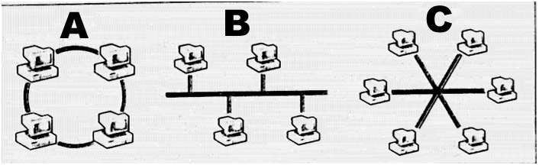

Network Type | Letter
Bus Network
Ring Network
Star Network
[3]

